Refugee Women: Barriers to Career Development

Refugee women have long been portrayed as helpless victims of war, dependent on their spouses for support, having no interest in work and lacking relevant skills to contribute to the economy of their host countries. The employment rates of refugee women are indeed quite low: in Europe only 45% of refugee women have a job compared to 62% of refugee men. In Germany - a country with one of the largest refugee populations - the gap is even wider, with only 29% of refugee women being employed in contrast with 57% of men. According to research by the Network IQ project, however, there is much more to the story behind these numbers than refugee women’s ‘helplessness’ and ‘laziness’. Refugee women face significant barriers that are hindering their career development. This article explores some of these barriers, shining light on the challenges experienced by refugee women when looking for employment.

You might wonder why one should care about refugee women’s career development. Well, according to a recent study by Georgetown Institute for Women, Peace and Security, refugee women have the potential to generate up to $1.4 trillion to the annual global GDP of the top 30 refugee-hosting countries, provided all earnings gender gaps are addressed beforehand. There are of course also benefits to the refugee women themselves: employment can give them more independence, improve their integration, and create a sense of confidence and empowerment.

It’s time to look past the negative stereotypes surrounding refugee women, and instead consider their bravery fleeing war zones, risking their lives to save their children, and their resilience adjusting to new cultural environments. How many of us have managed to overcome such hardship, and how well would we deal with such challenges if put in their shoes? Employers often emphasise the importance of skills such as cultural awareness, resilience and adaptability. Why then are these skills not recognised in refugee women? Refugee women have a lot of potential, and their loss of career development is a question of addressing the barriers they face in their host countries, not their helplessness or lack of interest in working. According to a study by the German Federal Office for Migration and Refugees, the majority of refugee women want to be in gainful employment.

Childcare and family commitments

Childcare commitments is one of the major barriers to refugee women’s career development. Many of the refugee women who arrive in their host countries have children but lack the family networks or connections they can rely on for childcare. Household tasks and childcare responsibilities in refugee families are often distributed unevenly, with women undertaking more unpaid household work. While this is also an issue faced by many women in general, refugee women are particularly vulnerable as the uneven distribution of labour limits their opportunities for undertaking language classes and building support networks, both of which are crucial to finding employment. Additionally, due to the language barrier, exacerbated by childcare responsibilities, refugee women often have poor access to information about employment, and are less aware of their rights and the opportunities available to them.

Mental health


Refugee women’s mental health is one of the most underestimated aspects of their lives. A substantial proportion of refugee women have experienced some degree of physical, sexual or emotional abuse, such as violence in their home contries, abuse during transit, sexual assaults by border conrol officials, and domestic violence that at times continues in their host countries after arrival. These experiences can have a severe psychological impact, affecting refugee women’s ability to work. Research has found that refugee women are particularly prone to developing Post Traumatic Stress Disorder (PTSD), depression, and anxiety-related problems such as memory difficulties. While male refugees also often struggle with mental health which may affect their career development, refugee women are more vulnerable due to the additional impact of sexual abuse and domsestic violence - experiences less common amongst male refugees.

False perceptions

In addition to the physical and emotional barriers, refugee women struggle against false social perceptions and negative stereotypes associated with the label of being a ‘refugee woman’. Refugee women are often rendered invisible in society or are stereotyped as victims with little agency, incapable of making their own decisions and reliant on their husbands and the state for financial support. Employers have a tendency to view refugee women as an unqualified, unskilled and inexperienced section of the population that has no potential or desire to work. Due to these perceptions, refugee women as a social group are rarely targeted by employers and have difficulty building networks, which limits their opportunities.

Unrecognised Professional Qualifications

Contrary to common perceptions, some refugee women are highly skilled, hold university degrees or other professional qualifications, and have a history of professional employment. In the UK for example, 28% of refugee women have professional work experience, and 18% hold higher education degrees. Most qualified refugee women, however, struggle to have their experience and qualifications recognised. In Germany, only 25% of women’s education qualifications are recognized, compared to 37% of men. Consequently, highly skilled refugee women often end up being demoted to positions below their qualifications: women who previously worked as school counsellors or teachers, find employment as cleaners or kitchen hands, while those previously working as scientists or industrial chemists are demoted to clerical roles. Oftentimes, skilled female refugees end up leaving their positions because of unequal pay, exploitation and a lack of recognition of their skills.

Institutional and legal barriers

The barriers to refugee women's career development are further reinforced by institutional frameworks and a lack of legal protections. Host refugee countries rarely mandate equal pay for equal value of work, and some even restrict women’s participation in certain industries. Turkey, for example, has the widest gender refugee pay gap, with female refugees earning just 6 cents for every dollar earned by a host man. Only 15% amongst the 20 host refugee countries surveyed by the International Rescue Committee allow refugees the same right to work as other citizens; 40% allow the right to work with strong restrictions and 20% do not allow refugees to work at all. Even when eligible for formal employment, refugees’ access to work in practice is often constrained by high fees, complex administrative processes or at times outright obstructions. Many countries that in principle allow refugees to work, place restrictions by limiting the sectors in which refugees can work, the geographical areas where they can seek work, or the number of refugees that can be employed by a certain firm.

Successful Refugee Women
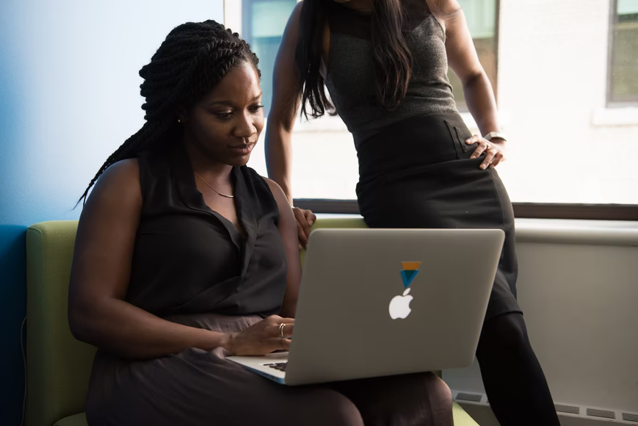
If provided the right opportunities, refugee women have the potential to achieve professional success and contribute to society. There are currently many women from refugee backgrounds such as Anxhela, an Albanian refugee, working on the Covid-19 frontlines. Anxhela came to the UK as a child and currently works as a junior doctor at a respiratory healthcare unit at the NHS. She says: "when I tell people I came to this country as a refugee, I now say it quite proudly."

There are also many refugee women who became successful entrepreneurs. Nada Hasan Kiblawi is an Iranian refugee who graduated from an American university with a degree in electrical engineering and now has her own consulting company and a charity foundation helping Palestinian tenagers living in refugee camps continue their education. Latifah Fathy Dorgham is a social entrepreneur from Palestine now living in Egypt. She worked as a civil servant for UNICEF and various human rights organisations, and has now launched her own initiative aimed at increasing awareness about social issues such as violence against women.

Most refugee women who have managed to achieve impressive professional success arrived in their host countries as children or young adults, and had the necessary family support, language skills and networks to help them succeed. Older refugee women do not have such luxury and face substantial career barriers, often having to sacrifice their own goals and dreams to give their children a better life and career opportunities that they can not have.

